Static website hosting :using s3 ,route 53 ,go daddy domain
what is Static website hosting ?
In AWS we can host a static website using amazon s3 (simple storage service)

how it works?
Create an s3 bucket
to uncheck block all public access and check acknowledgement
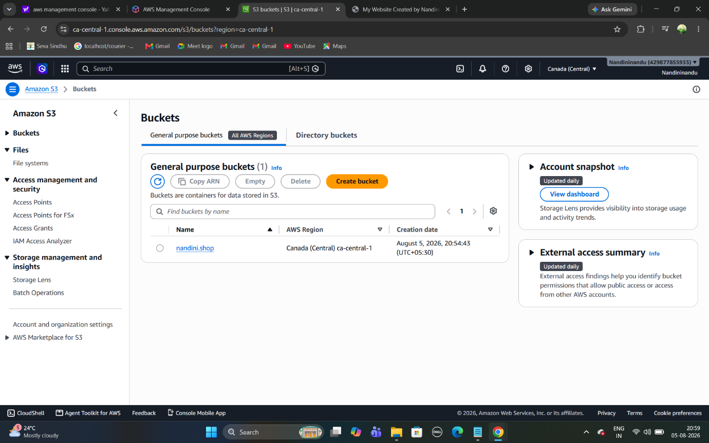

upload html css js and image files to bucket
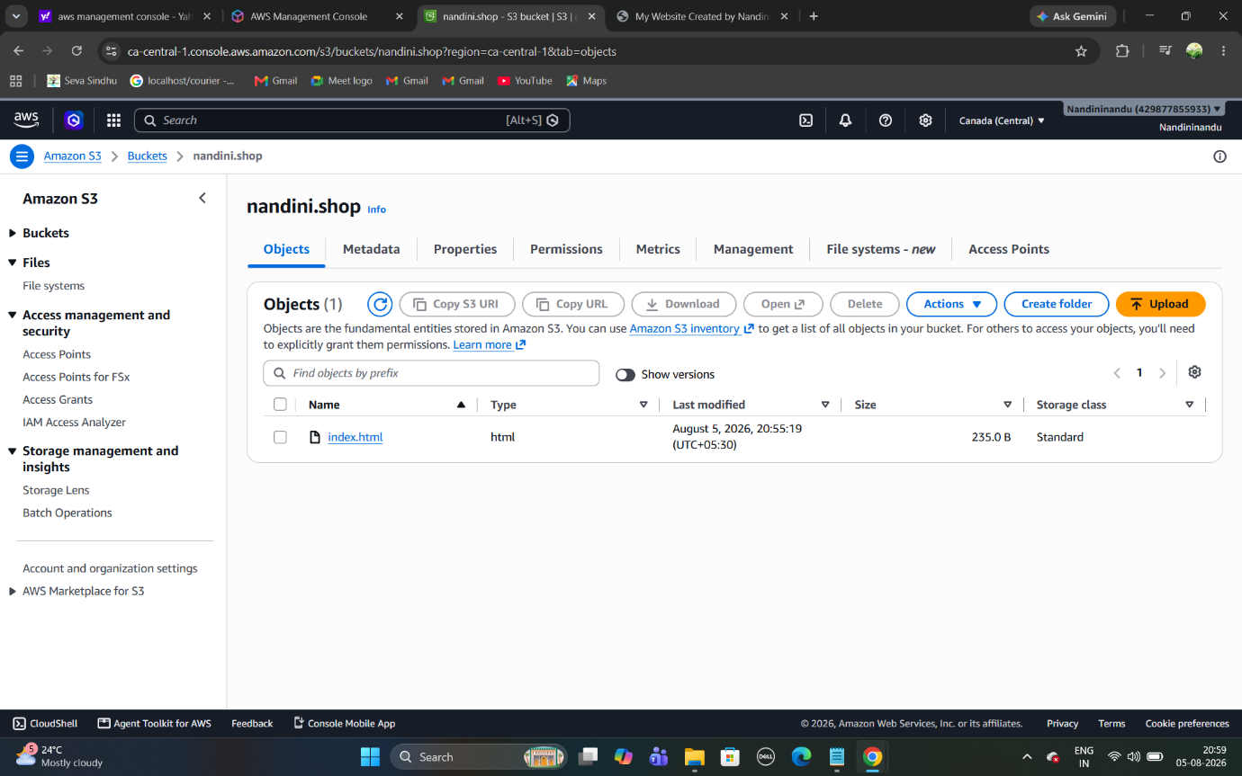

select properties and enable static website hosting
select permissions attach bucket json policy
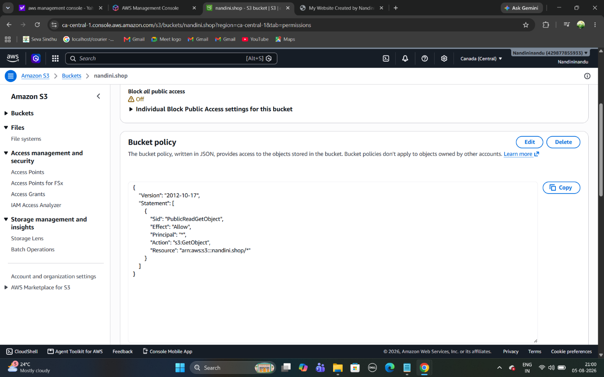
access the website using the s3 website endpoint

or
map our own domain using services such as amazon route 53
select route53 in that create hosted zones
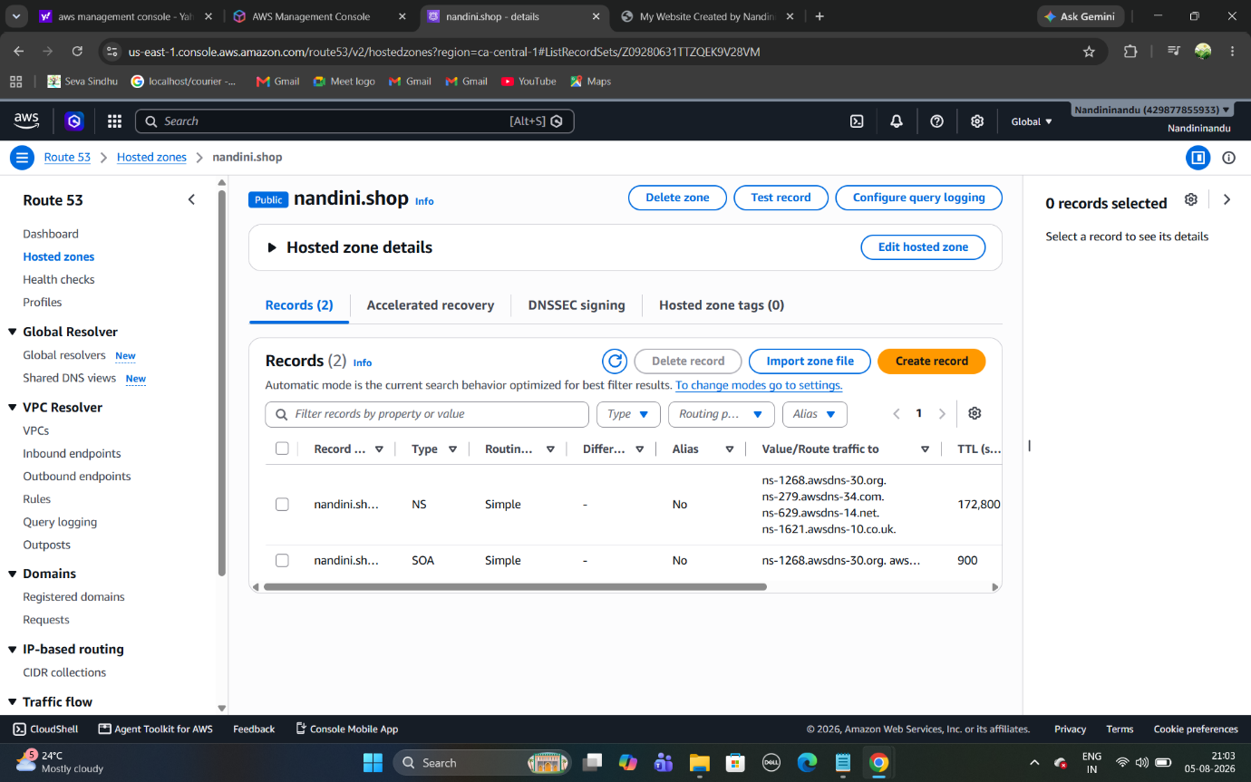
copy route values paste it in godaddy domain name servers
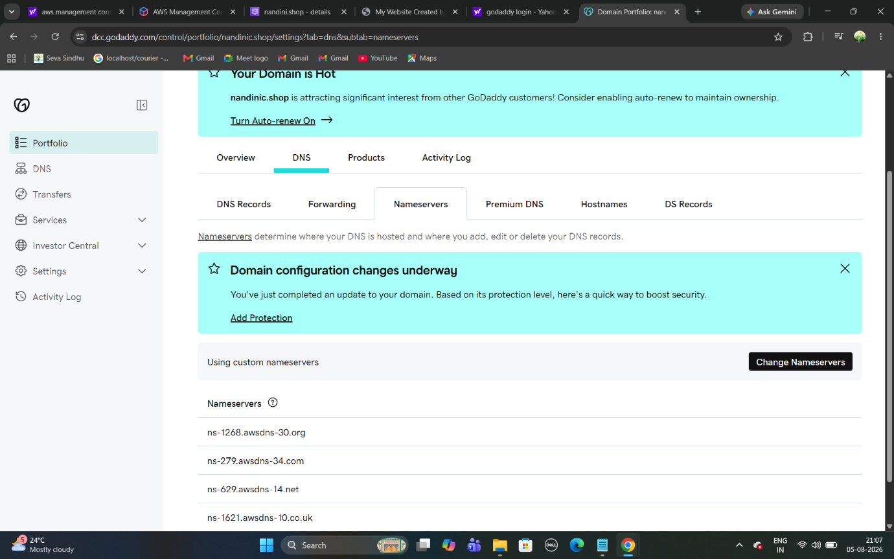

select hosted zone and create records
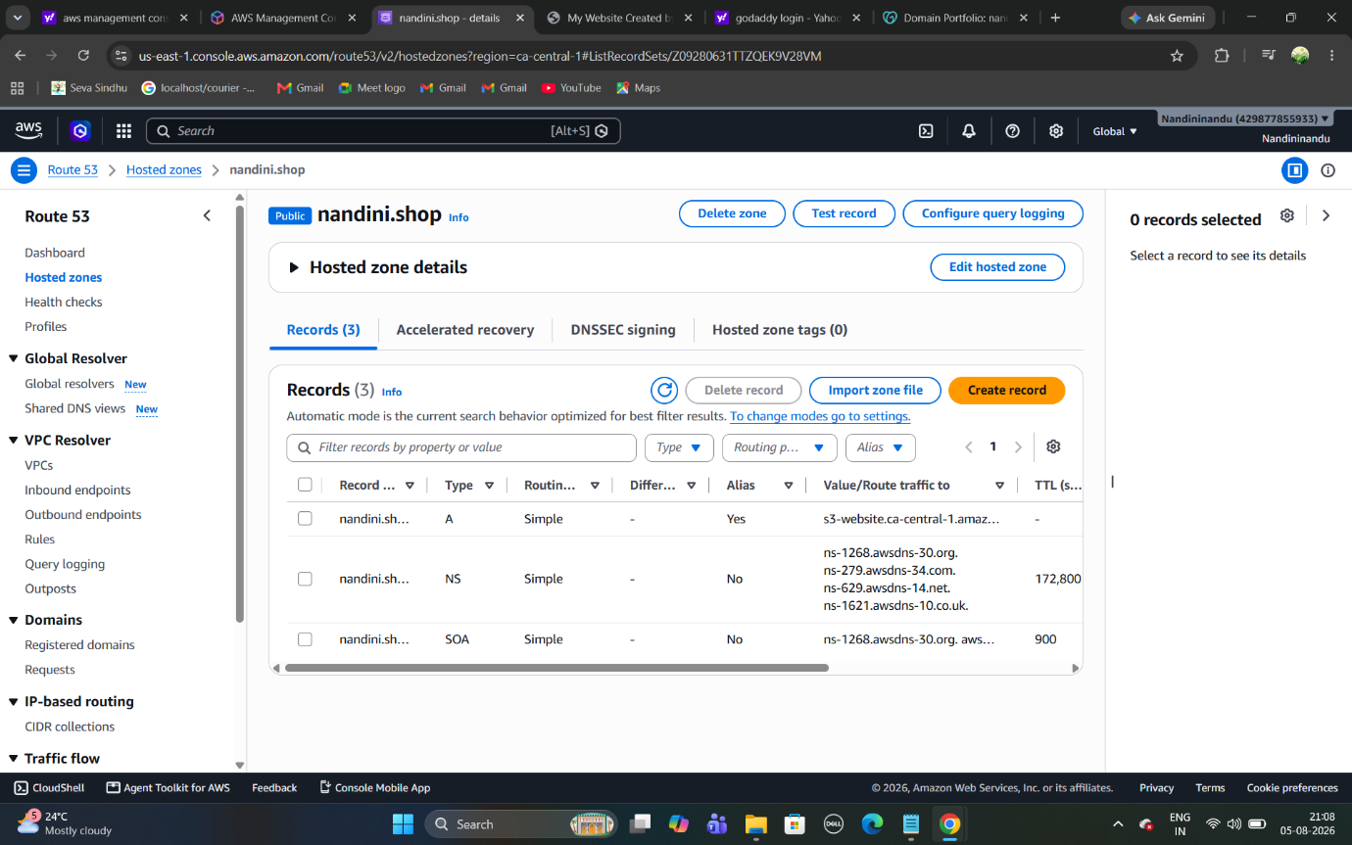

copy paste domain name in browser http://domainname
